Metal 3D Printer Commissioning

Report 2

Nathan Krikawa - Project Manager, CAD Engineer, and Manufacturing Engineer

Nolan Hann - Logistics Manager, Financial Manager, CAD Engineer, and Test Engineer

Fall 2024 - Spring 2025

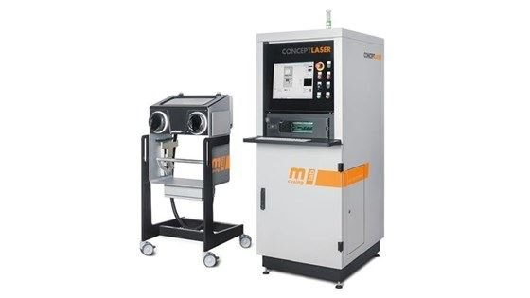

Project Sponsor: NAU Mechanical Engineering Department
Sponsor and Faculty Advisor: Constantin Ciocanel
Project Mentor: Mike Downey
Instructor: David Willy

DISCLAIMER
This report was prepared by students as part of a university course requirement. While considerable effort has been put into the project, it is not the work of licensed engineers and has not undergone the extensive verification that is common in the profession. The information, data, conclusions, and content of this report should not be relied on or utilized without thorough, independent testing and verification. University faculty members may have been associated with this project as advisors, sponsors, or course instructors, but as such they are not responsible for the accuracy of results or conclusions.

EXECUTIVE SUMMARY
Our project is the commissioning, testing, initial operation, and training development of a Concept Laser Mlab cusing R metal 3D printer. This printer was donated by Honeywell to NAU’s ME department and is currently stationed in NAU’s IDEA Lab in the engineering building. The goal is to have the printer fully functioning by the end of the 2024-2025 school year and ready to be integrated into the ME286L manufacturing lab curriculum as well as have it open for work orders from the IDEA Lab.
The printer uses laser powder bed fusion (LPBF) technology which fuses powdered metal together to form a part. This powder is often reactive with oxygen and requires an inert environment which we provide with argon gas. Unlike fused filament fabrication (FFF), the most common 3D printing technology, which extrudes thermoplastics from a nozzle to create a shape, LPBF uses a laser to melt extremely thin layers of powdered metal onto the previous layer. The first layer is spread across the metal powder bed with a blade, the laser melts it into the cross section of the part at that layer, the next layer is spread and melted, and that process repeats until the print is complete. The resulting print is surrounded and filled with loose metal powder which must be carefully removed before the part can be handled without safety equipment.
This project has multiple components that must be completed to succeed. The first of which is to install the printer and restore it to proper functionality. This printer was donated due to issues with build plate alignment and condensate leakage which were never resolved. Our first job is to install the printer by connecting it to power and argon gas supplies, then run test prints to identify the source of the alignment issue and the location of the condensate leak. We will fix these issues and replace parts if we are capable and qualified or hire a specialized technician if it is recommended to do so. For example, if the alignment issue has anything to do with the fiber laser system, we are not trained or qualified to tamper with it.
After the printer is up and running, we will print dog bone tensile test specimens and compare them to machined counterparts of the same material. We will be comparing a printed dog bone with an as-printed surface, another printed dog bone with a machined surface, then a machined dog bone. This will show us a comparison between printed and non-printed materials, as well as a comparison between machined and non-machined surface finishes of printed parts.
We will then print a final part to be implemented in an assembly for demonstration. The goal of this demonstration is to show off the capabilities of additive metal manufacturing by using topology optimization to print a part which would be impossible to realize with subtractive manufacturing. Topology optimization uses software to take the geometry of a part and maximize its efficiency under a specific load case by redistributing and subtracting material. This results in a much lighter part without compromising its structural integrity under that load case.
Finally, we will be putting together a simplified instruction manual with safety and operation procedures, as well as a training program that will walk a first-time user through their first print. The training program will be a step-by-step guide which covers software operation, machine operation, and safety procedures to print a single object of our choosing. This will be used by the IDEA Lab to begin training employees on the machine.
Currently, we are ordering the necessary equipment to install the printer and designing our initial test parts and possible final parts. The equipment includes a wet-separating vacuum for cleaning volatile powder, argon gas tanks and a stand for them, build plates, and a computer for the software. Our test prints are simple parts such as the famous “benchy” which will reveal alignment issues. We have also hired an electrician to install a compatible outlet in the IDEA Lab, which will allow us to work with the software and machine before final installation. After we have the required equipment, we are hiring a GE technician to ensure that the machine is safe and will begin printing directly after. Our current goal is to have the printer up and running with build plate alignment and condensate leakage issues fixed by the first few weeks of the Spring 2025 semester.

TABLE OF CONTENTS
Contents
DISCLAIMER 2
EXECUTIVE SUMMARY 3
TABLE OF CONTENTS 4
1 BACKGROUND 1
1.1 Project Description 1
1.2 Deliverables 1
1.3 Success Metrics 2
2 REQUIREMENTS 3
2.1 Customer Requirements (CRs) 3
2.2 Engineering Requirements (ERs) 3
2.3 House of Quality (HoQ) 4
3 Research Within Your Design Space 5
3.1 Benchmarking 5
3.2 Literature Review 6
3.2.1 Nolan Hann 6
3.2.2 Nathan Krikawa 8
3.3 Mathematical Modeling 9
3.3.1 Nolan Hann 9
3.3.2 Nathan Krikawa 11
4 Design Concepts 12
4.1 Functional Decomposition 12
4.2 Concept Generation 13
4.2.1 Final Part 13
4.2.2 Test Part 14
4.2.3 Test Specimen 14
4.3 Selection Criteria 15
4.4 Concept Selection 15
4.5 Commissioning Evaluation 15
5 Schedule and Budget 18
5.1 Schedule 18
5.1.1 Fall 2024 Gantt Chart 18
5.1.2 Spring 2025 Gantt Chart 18
5.2 Budget 19
5.3 Bill of Materials (BoM) 19
6 Design Validation and Initial Prototyping 21
6.1 Failure Modes and Effects Analysis (FMEA) 21
6.1.1 Metal Printer FMEA 21
6.1.2 Commissioning Process FMEA 22
6.2 Initial Prototyping 23
6.2.1 Skateboard Truck – Nathan 24
6.2.2 Bicycle Crank Arm – Nolan 30
6.3 Other Engineering Calculations 33
6.3.1 Topology Optimization Calculations – Nathan 33
6.4 Future Testing Potential 34
7 CONCLUSIONS 35
8 REFERENCES 36

BACKGROUND
This section discusses the overall goals and objectives of the project. This includes a description of the project, the deliverables expected, and what would constitute a successful project.

Project Description
The Metal 3D printer capstone, otherwise known as the Metal 3D Printer Commission, is a project to set up the IDEA Lab’s Concept Laser Mlab cusing R. This includes hooking the machine up to utilities, making sure it is in working order and troubleshooting if it is not, printing various parts to test the capabilities of the printer, and creating instructions for use by IDEA Lab managers.
Metal 3D printing, or additive manufacturing, has transformed the way industries approach production, allowing for rapid prototyping, mass customization, and on-demand manufacturing of metal parts. However, before a metal 3D printer can be used in an industrial setting, it must undergo a commissioning process to ensure that it operates efficiently and safely. This project was initiated to ensure that the new metal 3D printer meets stringent industrial requirements for accuracy, mechanical properties, and cost-effectiveness. The commissioning process will provide confidence that the printer can produce high-quality parts consistently.
The project will begin with the physical installation of the printer, followed by a visit from General Electric technicians to make sure the machine is in proper working order. Then the team will print various test parts to check the printer for any quirks or errors that might occur when printing. The final steps of the process are then noted in the next section.

Deliverables
- Working Printer: Install and restore printer to proper functionality, which is measured by accurate parts and a reliable printing process.
- Finished part with assembly: Print a final part as part of assembly using topology optimization, whether this assembly belongs to another team or is a project exclusive design.
- Test Specimen: Evaluate printed specimens against machined counterparts; this will be a tensile test comparing a traditionally machined dog bone specimen, printed stock machined to specification, and a fully printed specimen.
- Instruction Manual for IDEA Lab managers and curriculum for 286L: Create an instruction manual for training purposes in preparation for work orders and ME286L curriculum expansion. IDEA Lab managers should be able to easily operate the machine for work orders and keep a safe environment inside the lab. In addition, we are tasked with creating a curriculum for the Design for Manufacturing lab.

Success Metrics
The success of this project relies on several key technical requirements. The printer must produce parts with dimensional accuracy within ±0.1 mm, while maintaining surface roughness values suitable for the intended applications. Additionally, mechanical properties of the printed parts, such as tensile strength and density, must match or exceed 95% of those produced by traditional manufacturing methods. The system must also operate safely, meeting all relevant safety standards for handling metal powders, including proper ventilation, inert gas usage, and emergency stop mechanisms.
By the end of this project, the metal 3D printer will be fully commissioned, capable of producing high-quality metal parts with the precision and reliability required for whatever application undergrads or graduate students might need them for. This commissioning process will not only ensure that the machine operates within the desired technical specifications but will also provide a foundation for future use within capstone projects and the mechanical engineering department.

REQUIREMENTS
The requirements of this project are determined through a needs-based assessment of our customers and their desired outcome. Our customer is the ME department chair Dr. Ciocanel, as we are commissioning a machine for use by the ME department. This section will cover our customer’s requirements for our project, the engineering requirements for the commissioning of the machine, as well as a house of quality visual analysis of these requirements and their relations to one another.

Customer Requirements (CRs)
Our customer requirements represent the most important aspects of the project as defined by the customer. These are listed below with a description how they are evaluated:
- Ease of Use: Successful and efficient integration of our machine’s operating procedure with the existing workflow of the IDEA Lab. Quality of our training program.
- Safety: The safety of ourselves and all people in the IDEA Lab during and after operation of the machine. Includes strict adherence to safety protocols along with signs and notices of dangerous procedures and areas and required personal protective equipment.
- Time: Installation and repairs completed as soon as possible, with timely completion of deliverables such as the training program. Should be fully operational and ready for use by others by the summer of 2025.
- Successful Installation: Fully operational printer.
- Tensile Test Results: Comprehensive and accurate results which demonstrate printed material strength.
- Final Part and Assembly: Demonstrates capabilities of additive metal manufacturing. Part could not be manufactured with subtractive manufacturing. Part is designed with topology optimization for maximum efficiency.
- Instruction Manual: Completed training program along with a simplified operating and safety manual for future ease of use.

Engineering Requirements (ERs)
The engineering requirements of this project relate to our printing constraints and the physical requirements of the printer. These are listed below along with a description of each:
- Materials Tested: There is a wide range of materials that can be used in this machine including aluminum, stainless steel, titanium, and bronze. We will be using 316L stainless steel initially as it is safer than more reactive metals such as aluminum and titanium, and was donated to us by the U of A.
- Final Print Material: The main contenders for a final print material are 316L stainless steel, aluminum, and titanium. This will depend on our capabilities at the time as well as the desired strength and weight as determined by the assembly. This will affect customer requirements such as safety, time, ease of use, and final part and assembly.
- Final Print Volume: This is the main constraint of the machine, as we are limited to a print volume of 90 x 90 x 80mm.
- Power: The machine requires a 230V, 16A outlet to operate.
- Inert Gas: Nitrogen or Argon gas can be used to create an inert environment for the safe melting of powder. We will be using Argon gas as it is the most widely useable across different metals.
- Young’s Modulus Tested: The result of the tensile tests, to be measured in GPa. Normally 316L stainless steel tests at around 193 GPa.
- Dog Bone Size: Determined by print volume, testing apparatus, and availability of machined dog bones.

House of Quality (HoQ)
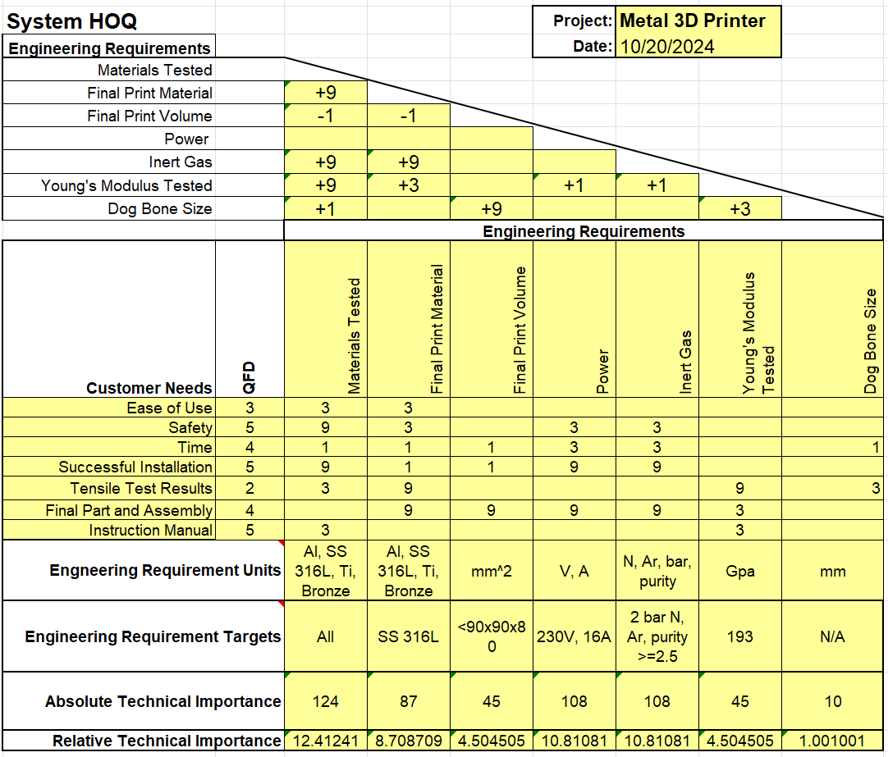
Figure 1: House of Quality

Research Within Your Design Space
This section of the report covers benchmarking, a literature review, and mathematical modeling and simulation. Benchmarking discusses the range of metal additive manufacturing within industry and the advantages and disadvantages of each type of process. The literature review details multiple resources used to better understand fundamental aspects of the project and additive manufacturing. Lastly, the mathematical modeling shows calculations and simulations relating to finalized parts and test specimen.

Benchmarking
Additive metal manufacturing is an emerging field of additive manufacturing (AM) which is still in its infancy. There are many different types of metal AM. Our metal printer uses the most common of them, LPBF, which uses a laser to melt layers of powdered metal in a powder bed. The current state-of-the-art within this industry is defined by build volume, build rate, and precision (resolution). The main constraint of LPBF is the build volume, and it excels in print accuracy and structural freedom. The bigger the machine gets, the more difficult it becomes to regulate inert gas flow and maintain the accuracy of the print. The current state-of-the-art LPBF system is the GE Atlas 3D printer [1]. This printer is the largest ever in LPBF with a build volume of 1.1 x 1.1 x 0.3m.
Other types of metal 3D printing are also commonly used and under development within the industry, and are similarly evaluated by build volume, build rate, and resolution. The second most common is binder jetting. This process also uses a metal powder bed, but instead of melting each layer with a laser, it extrudes a binding polymer across the powder in the cross section of the part. At the end of the printing process once the polymer is dry, the excess powder is poured and brushed away, and the printed object is heated to just below the melting point of the metal. This is called sintering and burns away all excess polymer and binds the metal powder into a solid metal object. This process is far less dangerous than LPBF in the printing stage yet suffers from high shrinkage and low density after sintering. The state-of-the-art machine in binder jetting is the ExOne X1 160Pro due to its high build volume of 800 x 500 x 400 mm [2].
Another emerging method of metal AM is direct energy deposition (DED). This is very similar to fused filament fabrication (FFF) plastic printing as it involves material being extruded and melted through a nozzle to create a print. DED is the process of melting powdered or wire metal as it comes out of a nozzle using a laser or electron beam. This material is then printed layer-wise to create a final part. The main advantage of this is that it can have far larger build volumes due to it not requiring a volatile powder bed. A disadvantage is that it has far lower resolution and precision. Leading to messier prints requiring high tolerance to be useful. The current state-of-the-art machine which uses this method is the EBAM® 300 Series [3]. This printer uses an electron beam to melt fed wire stock through a nozzle. This printer has a build size of 6096 x 1397 x 1371.6mm and can print up to 20lbs of material per hour, far surpassing the current possible build size and print rate of powder bed printing methods just with greatly reduced precision and resolution.

Literature Review

Nolan Hann
Operating Manual, Type: Mlab cusing R
This manual from the Hofmann Innovation Group provides detailed operational guidelines for the Concept Laser Mlab cusing R, a metal 3D printer that uses powder bed fusion (PBF) technology. The document covers essential aspects of machine operation, including setup, calibration, safety protocols, and maintenance procedures. It also provides instructions for optimizing printing parameters to achieve high-quality prints in various metal alloys. This manual is critical for technicians and operators working with the Mlab cusing R, as it offers comprehensive instructions to ensure proper machine function and maximize part quality, making it an important resource in the practical deployment of metal additive manufacturing systems.

Mechanics of Materials by R.C. Hibbler
This textbook is a foundational resource for understanding stress, strain, and deformation in materials under various loading conditions. It provides detailed explanations of tensile, compressive, and shear testing, emphasizing theoretical principles and practical applications. The book includes equations, diagrams, and examples relevant to engineering materials and their mechanical properties. The book's sections on stress-strain behavior and material properties are critical for designing and interpreting tensile tests. It explains concepts such as Young’s modulus, yield strength, and ultimate tensile strength, which are central to assessing a material's performance under tensile loads. This makes it an excellent guide for preparing tensile test setups, analyzing data, and understanding material failure mechanisms.

“Powder characterization techniques and effects of powder characteristics on part properties in powder-bed fusion processes.”
This paper provides an in-depth exploration of powder characterization techniques and their critical impact on part properties within powder bed fusion (PBF) processes. The authors examine the influence of various powder characteristics, such as particle size, shape, and distribution, on the final mechanical properties and dimensional accuracy of printed parts. The work is a valuable resource for understanding how powder properties affect performance in PBF and for developing strategies to improve print quality by optimizing powder materials. This study is particularly relevant for researchers and professionals working with metal additive manufacturing who are focused on improving part consistency and quality.

“Powder bed fusion processes: An overview.”
This chapter offers a comprehensive overview of powder bed fusion (PBF) processes, explaining the different variants, such as selective laser melting (SLM) and electron beam melting (EBM), while highlighting the technological challenges and opportunities presented by these techniques. The authors cover topics such as the influence of process parameters on build quality, thermal management, and potential applications of PBF technologies in various industries. This source is essential for anyone seeking a broad understanding of PBF processes and their application in metal 3D printing, making it a foundational reference for students, researchers, and practitioners.

“An overview of residual stresses in metal powder bed fusion.”
This article provides a thorough review of residual stresses in metal powder bed fusion, a key issue that affects the dimensional accuracy and structural integrity of 3D printed metal parts. Bartlett and Li discuss the formation mechanisms of residual stresses, their impact on part quality, and various methods for mitigating these stresses, such as post-processing heat treatments. The paper is especially useful for researchers focused on enhancing the mechanical performance of metal parts produced through additive manufacturing by addressing stress-related issues. It also offers insight into future research directions aimed at reducing residual stress through process optimization and material development.

"Surface Finish for 3D Printed Tooling: Advancing PBF Technology as a Production Tool | Blog."
This blog post by AddUp focuses on advancements in powder bed fusion (PBF) technology, particularly in improving surface finish for 3D-printed tooling. It discusses the importance of achieving fine surface finishes for production-grade tools and the techniques available to improve surface quality post-printing, including surface polishing and chemical treatments. The article is relevant for professionals in manufacturing seeking to implement PBF in production environments, as it provides practical insights into how surface finish affects tooling performance and how to overcome common challenges in metal 3D printing.

“Stress-Strain Concepts: Why They Matter in Materials Testing.”
This blog post from Materion explains the fundamental concepts of stress and strain in materials testing, emphasizing their importance in understanding the mechanical behavior of materials under load. The article discusses how stress-strain curves can reveal critical information about material strength, elasticity, and ductility, which is crucial in determining the performance of materials used in industrial applications. This resource is useful for engineers and researchers involved in materials testing and quality control, as it offers clear explanations of key mechanical testing concepts relevant to additive manufacturing and metalworking.

“All About Tensile Testing: How to Set Up Your Samples for Accurate Results.”
This article from Materion provides an in-depth guide to tensile testing, covering how to properly set up and prepare samples to ensure accurate test results. It highlights the importance of sample geometry, gripping methods, and the alignment of testing machines in obtaining reliable tensile strength data. The article serves as a practical guide for engineers and technicians involved in testing materials, particularly those working with 3D-printed metal parts, where accurate tensile testing is essential for validating mechanical properties and ensuring product quality.

“Additive manufacturing of metals — Finished part properties — Post-processing, inspection and testing of parts produced by powder bed fusion”
This document specifies requirements for the qualification, quality assurance and post processing for metal parts made by powder bed fusion. It also specifies methods and procedures for testing and qualification of various characteristics of metallic parts made by additive manufacturing powder bed fusion processes, in accordance with ISO/ASTM 52927, categories H and M. This standard is helpful for adjusting and post processing any parts that were made by the school’s machine so that they are up to industry standards for additive manufactured parts.

“Standard Practice for Reporting Data for Test Specimens Prepared by Additive Manufacturing”
This standard specifies a standard procedure for reporting results by testing or evaluation of specimens produced by additive manufacturing. establishes minimum data element requirements for reporting of material and process data for the purpose of: Standardizing test specimen descriptions and test reports, assisting designers by standardizing AM materials databases, aiding material traceability through testing and evaluation, and capturing property-parameter-performance relationships of AM specimens to enable predictive modeling and other computational approaches. This standard is important for

Nathan Krikawa
“Selective Laser Melting: Materials and Applications”
This book by P. Konda Gokuldoss goes in depth on the selective laser melting (SLM) process which our machine uses. This was a good introduction to the industry and made the machine far simpler and more accessible in the early stages of the project. The book covers all different materials used by the industry in this process and the major applications of SLM on a commercial scale.

“Introduction to Finite Element Analysis & Design, Second edition”
This book by N. H. Kim, A. V. Kumar, and B.V. Sankar explains finite element analysis through both hand calculations and simulations. It goes from the very basics of what finite element analysis is and is used for, all the way into the most complicated application cases. This was a huge help when becoming familiar with finite element analysis in preparation for topology optimization.

“Research of 316L Metallic Powder for Use in SLM 3D Printing”
This paper contains detailed analysis of the material properties of 316L metallic powder before and after SLM printing and goes into very fine detail about how the laser melting process affects the molecular structure of the material and what this means for final prints. Once we decided to use this material, this source was a goldmine of what to expect and why when it comes to tensile testing and final print properties.

“Multiscale Analysis of Surface Texture Quality of Models Manufactured by Laser Powder-Bed Fusion Technology and Machining from 316L Steel”
This paper by D. Gogolewski, T. Barkowiak, T. Kozior, and P. Zmarzly covers much of what we plan to test regarding tensile testing and printed vs. machined print surfaces and will be very useful to reference as we do our tensile testing. Surface quality is a big part of final part production and this paper studies the exact material we plan to use.

“Topology Optimization in Engineering Structure Design”
This paper by W. Zhang, J. Zhu, and T. Gao, is an in-depth explanation of topology optimization, specifically for structural design in engineering. This is extremely useful as we dive into topology optimization. This covers how and when to use topology optimization, common use cases and misconceptions, and methods for producing optimal designs with topology optimization.

“Topology Optimization 101: How to Use Algorithmic Models to Create Lightweight Design”
This article by Formlabs contains a detailed guide to using topology optimization to reduce the weight of designs while retaining structural integrity. This is a very top-level guide but is useful in understanding the use of topology optimization and planning how it would best be applied to a final part.

“Powder Bed Fusion | Additive Manufacturing Research Group”
This article from Loughborough University covers their projects related to LPBF and what they have encountered and put research efforts into. This served as a good representation of the current university state-of-the-art system and helped plan research and design topics that we want to focus on at NAU.

“Metal 3D Printer Precision System | Objective 3D”
This article contains all the manufacturer specifications of our Concept Laser Mlab cusing R metal 3D printer in brochure format and is a very useful reference material when looking at its power and gas requirements as well as its build plate, material, and resolution specifications.

“F3592 Standard Guide for Additive Manufacturing of Metals – Powder Bed Fusion – Guidelines for Feedstock Re-use and Sampling Strategies”
This standard is intended to support AM users with the selection of the optimum re-use strategy for their AM process and provide guidance on how to implement re-use strategies in their organization. This guide suggests possible control measures that AM users can use to maintain powder quality, and factors to consider when validating selected re-use strategies, including guidance on sampling techniques.

“F3184 Standard Specification for Additive Manufacturing Stainless Steel Alloy (UNS S31603) with Powder Bed Fusion”
This standard for the usage of 316L steel in powder bed fusion from 2023 is a great up-to-date resource that we will be referencing often throughout this project. It covers everything we need to know about the material, how it prints, and how best to utilize it for good results.

Mathematical Modeling

Nolan Hann
Finite Element Analysis Simulation – Tensile Testing
Pictured below are two dog bone samples simulated with SolidWorks [20], the first of which follows a traditional ASTM D638 design and the second is a cylindrical design. They both were tested using SS 316L as the material and 40 kN of force in tension, specifically applying 20 kN to the tops and bottoms of the parts. This may be similar or identical to the specimen we plan on printing and machining for comparison testing, so understanding where the material should ideally fail would help us understand the weaknesses of a printed part. Similarly, this could help us better understand where failure could occur on a part and orient the print in such a way that it can mitigate a layer-based shear.

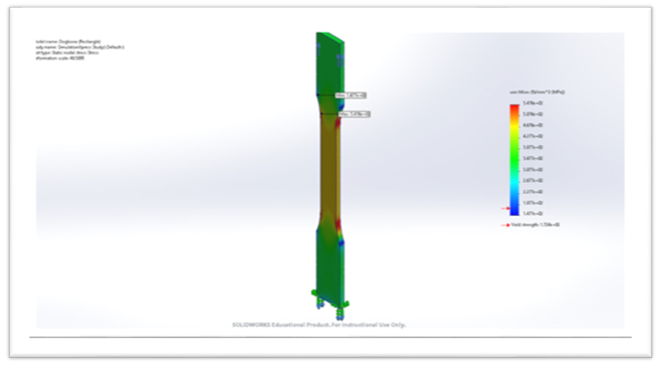
Figure 2: Finite Element Analysis - Squared Dog Bone

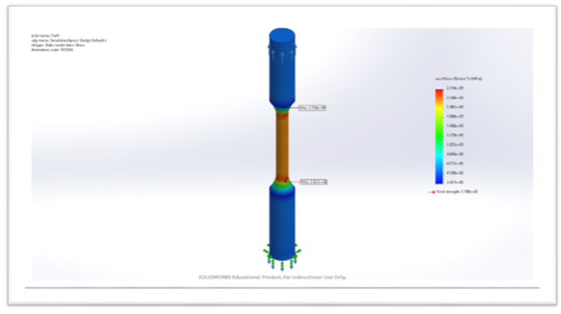Figure 3: Finite Element Analysis Simulation - Round Dog Bone

Nathan Krikawa
Finite Element Analysis - Hand Calculations:
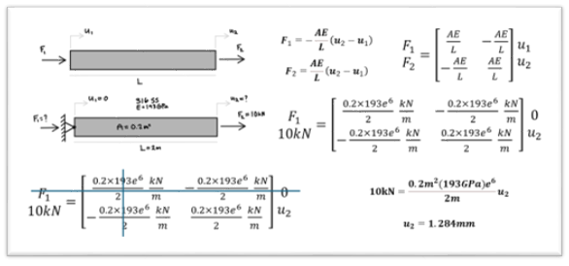
Figure 4: FEA Hand Calculations

I performed basic finite element analysis hand calculations on a single element to further understand it from an internal point of view as shown in figure 4 above. This proved very useful when later using SolidWorks simulations to complete this for a full object, as I understood exactly what was happening and why.

Finite Element Analysis Simulation - Simple Bracket Analysis
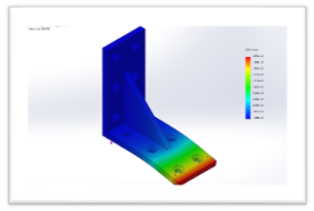
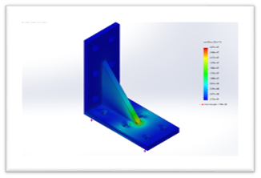
This is a full simulation of the effect of a static 300lb load on a simple 316L steel bracket I made in SolidWorks [20]. The bracket is fully supported on one side with a distributed load on the other. The next step will be to use topology optimization to decrease the weight of the bracket while maintaining the stress zones of this structure.
Figure 5: Topology Optimized Skateboard Truck
Figure 6: Bracket FEA Simulation - Displacement

Design Concepts
This section of the report covers the functional decomposition of the printer’s parts and functions, and final part concept generation and selection.

Functional Decomposition
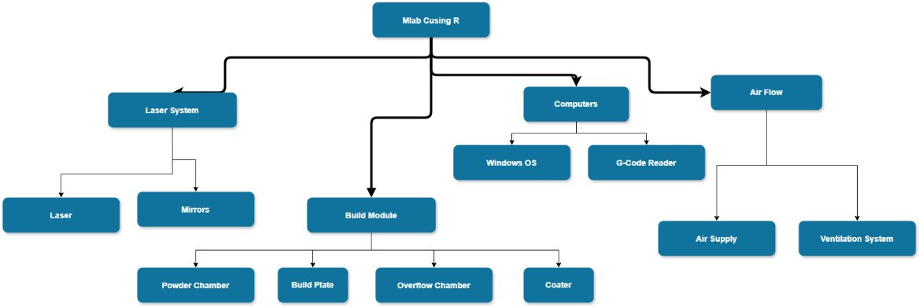Figure 7: Physical Decomposition of Mlab cusing R 3D Printer
The printer itself can be broken down into four of its most important systems: The laser, the build module, the computers, and its airflow.
The laser itself is comprised of two components, the Yb: YAG fiber laser and various mirrors. The former component produces the high-powered laser through its transport fibers and through its lens, where it is then concentrated into various mirrors that adjust the position of the focused beam on the build plate.
The build module relies on four components, the powder chamber, the build plate, the overflow chamber, and the coater. The powder stock is first poured into the powder chamber, where it is stored and fed during the build process. A motorized plate allows the powder to be lifted to a level where the coater blade sweeps along the X axis and brushes powder over the build plate. The build plate is a detachable component made of whatever material is currently being used in the print to allow the part to be welded properly. As the printing progresses, the plate slowly lowers itself to compensate for the growing height of the part. Any excess powder is swept into the overflow chamber. The chamber funnels any excess powder into reusable containers for storage.
There are two computers within the machine, a front-end Windows desktop, and a G-Code reader. The former of the two is the user interface of the machine, where files can be stored and accessed, as well as the machine’s parameters can be adjusted. This computer then informs the second computer of what part was selected for printing and how the file was sliced. The second computer then translates the sliced parts into instructions for the machine's mechanical components to perform.
The final system of the printer is the air flow. This is performed mostly by its ventilation system, which receives a supply of inert gas (either Argon or Nitrogen) and manages its flow across the build chamber of the machine. The air is then sent through filters to remove excess condensation and powder that is transported during the build.

Concept Generation
As a commissioning project, our concept generation is limited to three areas of design that will be used in later parts of our project. For each area we developed a few basic designs that will be selected from. These areas include final part designs, test part designs, and dog bone designs.

Final Part
For our final part we need a design that demonstrates the capabilities of the metal printer by designing a part which is impossible to create through subtractive manufacturing. The way we will do this is by replacing previously solid sections of a part and subtracting material from them through topology optimization and lattice structures. This will reduce the weight of the part without compromising its structural integrity, increasing the performance of the assembly.
The three concepts we developed for our final part are a fastener (bolt, screw, etc.), a bracket, and a larger component scaled down (skateboard truck for example). The fastener would be hollowed out in a modeling software and filled with a lattice structure to reduce the weight, greatly reducing the total weight of the assembly if many of these fasteners are used. This would also be easy to mass produce as one print could theoretically contain around 10 fasteners depending on their size.
A bracket is a common component in structures and would be easily implemented into an assembly. We would use topology optimization to reduce the weight and introduce complex geometries that would nicely demonstrate the capabilities of the printer.
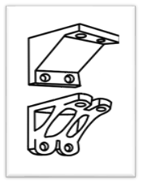
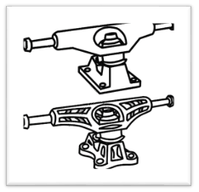
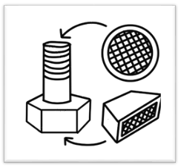
A larger component which is scaled down would allow a lot more design freedom, as we would otherwise have to deal with the limited print volume when considering assembly options. For this example, we are using a skateboard truck. This would be topology optimized and has the potential to also include a lattice structure. This would also be the most visually appealing as part of a small skateboard assembly.
Figure 10: Topology Optimized Skateboard Truck
Figure 9: Topology Optimized Bracket
Figure 8: Fastener with Lattice Structure

Test Part
Our test parts are intended to find the alignment issue with the printer and trace it back to the source of the problem. The best prints for this use case are ones with steady curves, complex geometries, and visual reference points to level surface axes. Our three designs for the test part are a benchy, a miniature figurine, and a bevel gear.
A benchy is a very common test print which comes installed on many plastic 3D printers and is widely used as a first print to test printer calibration and alignment. It has many differently angled surfaces, flat surfaces, and curved surfaces, along with some overhang and interior geometry.
A miniature figurine would provide high detail to test printer resolution, overhang, and also contains many different surfaces to find any printer alignment errors.
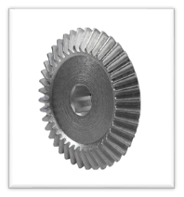
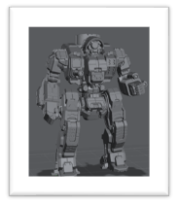
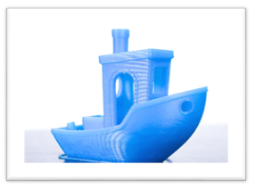
A bevel gear would be a very simple print, and due to its low tolerance and visual simplicity it would be easy to find alignment errors among its teeth and along its wide surfaces.
Figure 13: Bevel Gear
Figure 12: Miniature Figurine
Figure 11: Benchy

Test Specimen
The concept generation for the test specimen is quite simple. There are two possible test specimen that we will use: a rounded dog bone specimen, or a flat dog bone specimen. This is entirely dependent on the testing apparatus we are granted access to. The size of the printed specimen will be determined by the machined specimen we purchase or order to be manufactured and must fit within our build volume.
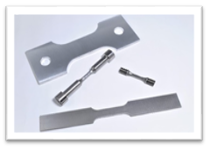

Figure 14: Dog Bone Specimens

Selection Criteria
The selection criteria between our concepts are slightly different for each area of design. For the final part, the selection criteria are that they cannot be manufactured through subtractive manufacturing, use topology optimization, are visually appealing, and apply to a greater assembly. For the test part they must have both flat and curved surfaces and some sort of intricate geometry to be able to spot an alignment error. For the test prints, selection is not as important as we may use multiple as we test the machine. Lastly, for the dog bone, the selection of design will be purely based on the testing apparatus we are allowed to use.

Concept Selection
Regarding our final part, we have decided to move forward with the idea of scaling down a larger component for printing. Not only will this be more visually appealing than something like a bracket or a fastener when assembled with a larger assembly, it also allows us more design freedom when using modeling software and performing topology optimization, as we can modify the assembly to match our part, rather than being confined to a specific existing assembly. Our two scaled down part concepts are a bicycle crank arm and a skateboard truck, which we have moved forward with through modeling and topology optimization (see sections 6.2 and 6.3).
For our test part, we will be using a combination of the above part ideas (section 4.2.2), choosing as necessary based on the specific problem areas that arise during prints to narrow down on any alignment or support issues. There are also possibly existing build files within the machine itself from its previous owners that can be printed with minimal software manipulation that could reveal to us hardware issues such as alignment.

Commissioning Evaluation
For this section, since we are primarily a commissioning project rather than a design project, we have laid out our entire commissioning process into a list format to better understand where we are in the process and what we need to accomplish to complete the project. Each major step of the list is followed by sub sections and their details and explanations.

1. Needs Assessment:
- Requirements
  - Equipment: Wet-separating vacuum, argon tank holder, PPE, wire EDM/bandsaw, etc.
  - Software: Magics
  - Lab: 230V outlet, chemical disposal
- Consultation with Stakeholders
  - Mike Downey: Industry expert and donation involvement.
  - Dr. Constantin Ciocanel: ME Department Chair and project sponsor
  - Honeywell and U of A: Industry standards and successful installation

2. Vendor Selection and Procurement
- Vendor Research
  - Equipment
  - Electrician
  - GE health check and upgrade
- Request for Proposals
  - Quotes for equipment
- Evaluate Proposals
  - Compare quotes
- Contact Finalization
  - Order equipment and submit work orders

3. Pre-Installation Planning
- Site Preparation
  - Meet with chemical safety representative in IDEA Lab: ventilation, safety procedures, machine and gas placement, etc.
- Infrastructure Checks
  - Install 230V outlet
  - Ensure safe disposal area

4. Installation and Setup
- Installation
  - Manual installation guide
- Software Setup
  - Install Magics on new computer
  - Ensure existing machine software is operational

5. Testing
- Initial Calibration and Configuration
  - Built in software configuration and machine calibration
- Safety Testing
  - Test emergency stops, ventilation, etc.
- Functional Testing
  - Without material, then with material
  - Starting with small prints
- Troubleshooting
  - Find alignment issues and determine cause
- Machine Repair
  - Determine if external technician needed for repair
  - Fix issue

6. Training
- User Training
  - First print tutorial with model and full instruction manual: How to slice a model in Magics, upload and use printer software, and run printer.
- Maintenance Training
  - IDEA Lab employee will need to maintain printer

7. Ongoing Maintenance and Support
- Regular Maintenance
  - Maintenance schedule and instructions
- Vendor Support
  - Maintain GE contact for repairs and support

8. Documentation Handover
- Documentation
  - Ensure manuals and safety documentation are available and easily accessible

Successful commissioning will entail a fixed and fully operational printer with a safe and repeatable printing procedure ready to be taught to IDEA Lab employees and implemented into the ME 286L curriculum.

Schedule and Budget
This section covers our Gantt chart schedules, our total project budget, and our updated Bill of Materials. In the schedule section is both our Fall 2024 semester Gantt chart as well as a rough draft of our Spring 2025 semester schedule. Our total project budget is determined by the ME department and expands continually as our project progresses, however the process by which our budget is determined is outlined below. Lastly, our Bill of Materials (BoM) for the project thus far is shown as well.

Schedule

Fall 2024 Gantt Chart
Our Fall 2024 Gantt Chart contains all the capstone deliverables for the first semester as well as our specific project deliverables and anticipated completion dates. These specific deliverables include study of the manual, our visit to U of A and Honeywell, ordering the electrician, ordering all the necessary equipment for the installation, meeting with the chemical safety rep for the installation of the printer in the IDEA lab, and the GE health check which includes getting a quote and having them come to NAU.

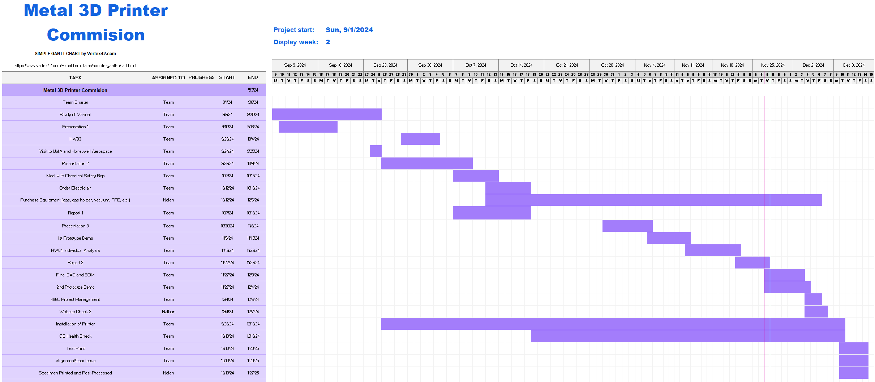
Figure 15: Fall 2024 Gantt Chart

Spring 2025 Gantt Chart
Our Spring 2025 Gantt chart is a first draft of what we need to get done and when in the second semester of capstone. This includes tentative capstone deliverables for next semester. The top section of the Gantt chart details all possible capstone deliverables and the time we plan to work on them for. The bottom section is for our specific project deliverables such as our initial test prints, dog bone specimen prints, final part design and print, and the writing of our instruction manual.

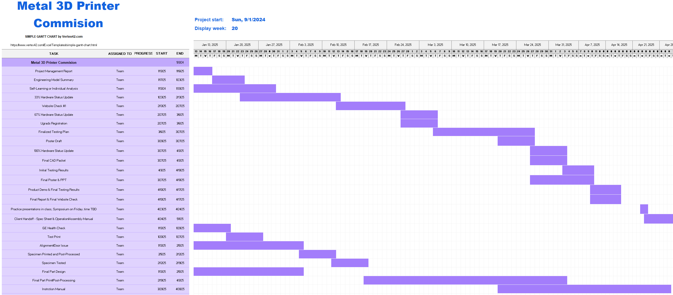
Figure 16: Spring 2025 Gantt Chart

Budget
Currently, the project has no set budget as the project is fundamentally quite different than the other design projects in our cohort. Seeing as we are commissioning a piece of equipment to be used by future students at the university, the college hasn’t set a clear maximum amount the project can spend. The Dean’s office has officially diverted an additional $5,000 grant towards our project which we plan on immediately putting to use in procuring essential materials for the project. Currently we have made two five-figure purchases towards the printer and are currently in the middle of potentially having Colibrium Additive make a visit and run diagnostics and install a few upgrades on the printer. In the future, we see most of our costs going into purchasing powder stock and Argon gas for continued use of the machine.

Bill of Materials (BoM)
Here is a list of materials that are required for safe and successful operation of the printer. Note that cells in Yellow are currently ordered and cells in Green have been received. What is not currently listed is our procurement of Argon gas for the printer’s inert air supply. Currently we’re unsure of the avenues to purchase and receive a consistent supply of gas tanks or if we should set up a system for the IDEA lab to request the material themselves.
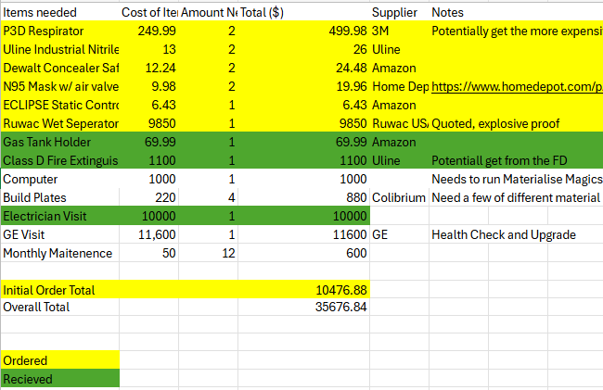

Figure 17: Bill of Materials

Design Validation and Initial Prototyping
This section contains our FMEA of the metal printer and the commissioning process, as well as prototypes for our final print and their subsequent topology optimization simulations and results.

Failure Modes and Effects Analysis (FMEA)
Failure modes and effects analysis is a process that helps to identify all possible failures in a design, the criticality of those failures, and how to identify and address them when they occur. Since our commissioning process is just as prone to failure as the metal printer itself, we have performed an FMEA on both to increase our awareness of and preparedness for potential failures.

Metal Printer FMEA
Seeing the operation of the machine is paramount to the commission’s success, it is critical to understand what could go wrong with the printer and how such a failure could be prevented. Much of the combative measures to avoid many of these issues is to regularly maintain the machine and check for any major signs of wear or corrosion as well as to run various performance tests on the moving parts of the build chamber. It was determined that the systems most crucial to the printer and most likely to experience failures were the laser system, build module, air flow, and the computer. These can be seen in figure below.

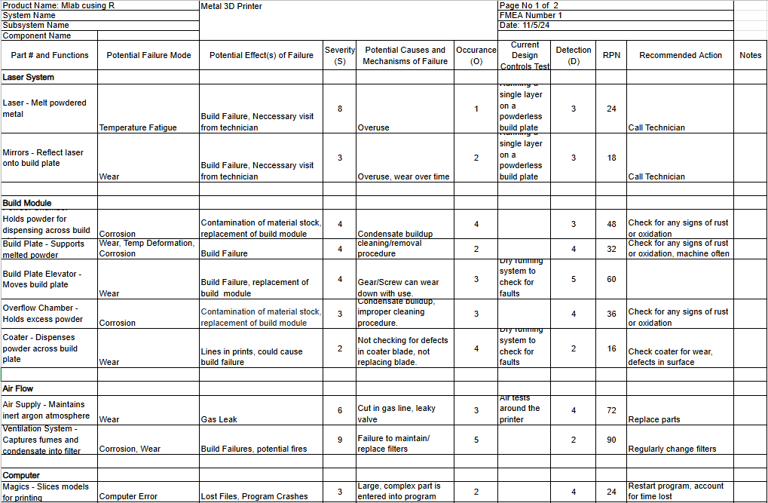
Figure 18: Machine FMEA

The component most susceptible to failure occurs with the air supply. While visiting U of A’s laboratory, the professor in charge had informed us that the components dealing with the air supply tended to be the most dangerous part of the process. Metal condensate tends to form within the air filter located on the side of the machine, and the condensate is often the most dangerous form of the metal powder. While aluminum and titanium are oxidizers and are dangerous to fill and replace within the machine, their condensate can ignite with sudden movement. As such, careful removal and replacement of the filters should be conducted regularly to prevent fires. Another issue that was discovered with the air supply, or at least an issue with U of A’s printer was the occurrence of a gas leak. Although it was not hazardous in anyway, whenever they would print the air supply would decrease far more than it should be using. This results in them running out of inert air much faster and requires them to replace the supply more often. While this isn’t as serious of an issue for them since they have a cryogenics department that supplies them with air, we have no access to anything like that and are required to purchase our own gas.

Commissioning Process FMEA
The most critical potential failures regarding the commissioning process are in the purchase orders, installation, troubleshooting, and final part and assembly. The failure modes of each of these aspects of the process is relatively similar, and generally concerns some sort of delay in the process. These failure modes can be seen in figure 15 below.

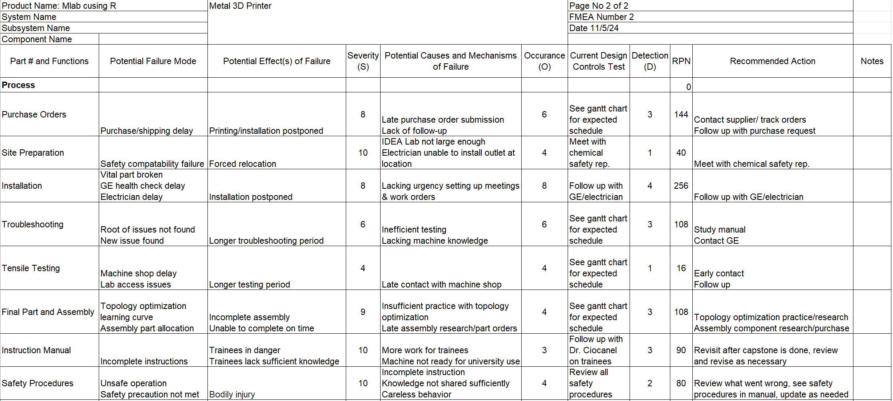
Figure 19: Process FMEA
To mitigate these potential failures, the main combative procedures are to stay in contact with outside resources (GE, Honeywell, ME department chair), stay ahead of the learning curve (topology optimization, machine software), and to frequently update and review our Gantt chart to stay on track and consistently have a clear vision for the future of the project.
For purchase orders, to stay on track we must consistently contact suppliers and/or track orders to plan efficiently for their arrival and follow up with our purchase requests to ensure they are placed in a timely manner. For the installation itself, aside from ordering all the necessary equipment, we must stay in contact with the electrician and GE who are integral to a successful installation. The electrician is responsible for installing an outlet to power the machine, and GE will be sending a representative to perform a health check and install an upgrade to the machine to make sure we are able to print safely. Both must be completed in a timely manner to ensure that we are able to print. Troubleshooting comes after this and involves the software and hardware operation of the machine. If we hit a major roadblock after GE comes this could cost us a lot of time, and our only options are to review the manual and contact GE. To mitigate this, we will study the manual completely beforehand and bring up any potential issues to GE when they come to service the machine. Lastly, for the final part and assembly, the main possible failure modes are the topology optimization learning curve being steep and taking a long time, as well as collecting/creating the necessary parts for the assembly taking a long time once the final part is printed. The recommended action for this is to get an early start on both processes; getting practice in topology optimization and the subsequent modeling that is required and planning where we will get our assembly parts from and if we will have to make them ourselves.

Initial Prototyping
This section contains our original models for the final print options, as well as our topology optimization simulations thus far. Topology optimization is a shape optimization method which uses algorithmic models to optimize material layout within a user-defined space for a given set of loads, conditions, and constraints. This removes any material that is not necessary for the structural integrity of the model for the specified conditions. I used SolidWorks for this topology simulation.

Skateboard Truck – Nathan
Topology Optimization Parameters
The two main parts of the skateboard truck model are the hanger and the base, which combined contain the bulk of the material and weight in the truck assembly (figure 1). These are the models on which I performed topology optimization and benefit the most from weight reduction. I performed two simulations for each part: one for 40% weight reduction, and another for 60% weight reduction. The loads, conditions, and constraints for the simulations are as follows:

Loads:
Hanger:
- Vertical impact load on ends of truck: 6345N
- Horizontal impact load on ends of truck: 5186N
- Vertical impact load along the truck: 4927N
Base:
- Impact load separately on both kingpin hole and pivot socket: 6345N
- This was chosen as it was the highest load on the truck, and therefore the worst-case scenario.

Conditions and constraints:
Both:
- 316L stainless steel
- Symmetry across x-z plane
- 40% and 60% weight reduction (separate)
Hanger:
- Fixed at pivot rod and kingpin hole (see figure 1)
Base:
- Fixed at bolt holes in corners

Schematics
Skateboard truck model:

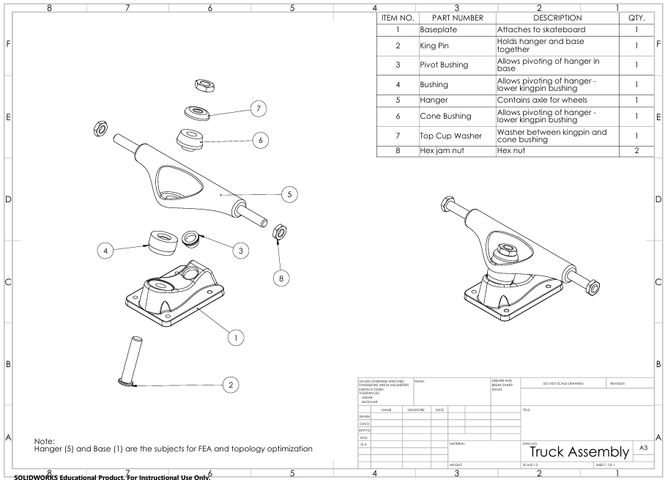
Figure 20: Full truck assembly drawing

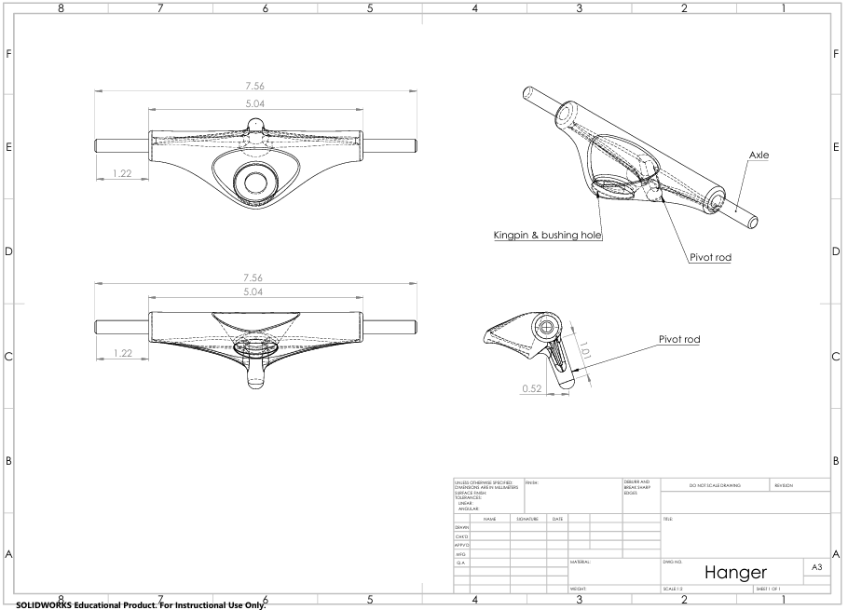
Figure 21: Hanger drawing

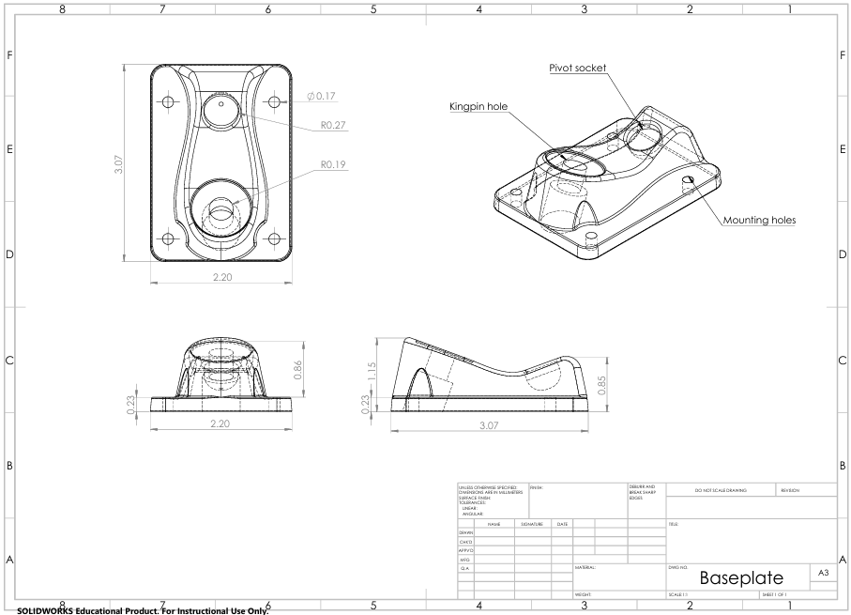
Figure 22: Base plate drawing

Hanger Optimization Results
Hanger 40% weight reduction:

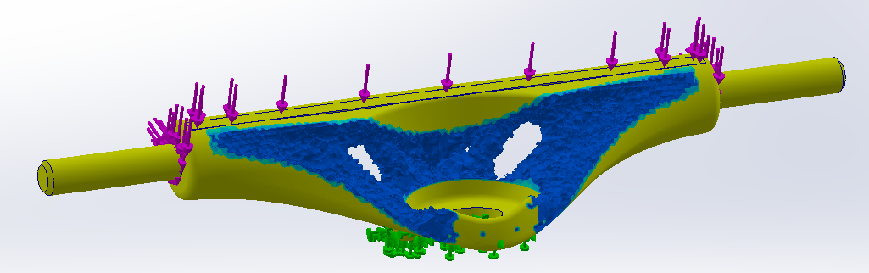
Figure 23: Optimized hanger 40% weight reduction front

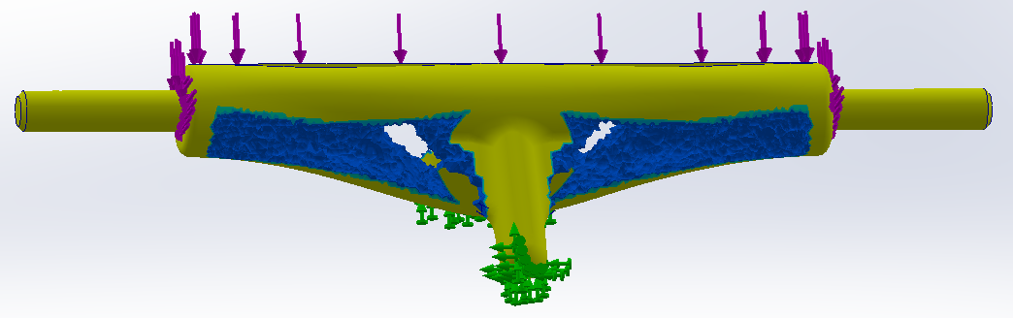
Figure 24: Optimized hanger 40% weight reduction back

Hanger 60% weight reduction:

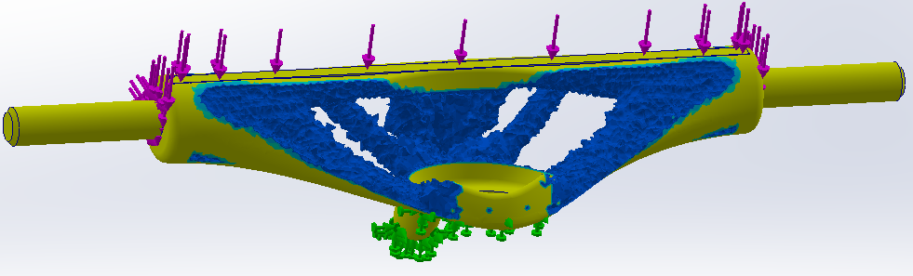
Figure 25: Optimized hanger 60% weight reduction front

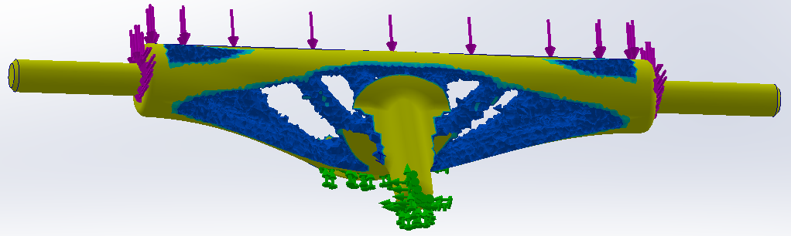
Figure 26: Optimized hanger 40% weight reduction back

Base Plate Optimization Results
Base plate 40% weight reduction:

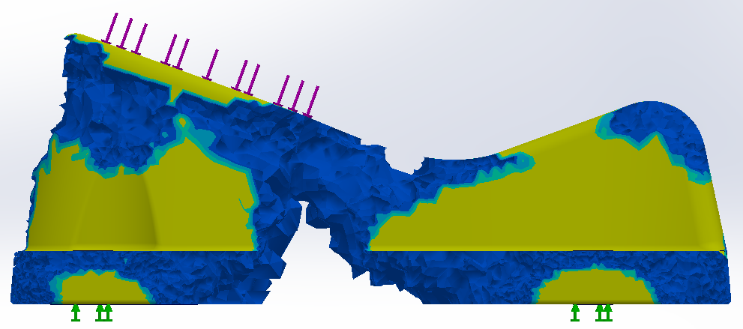
Figure 27: Optimized base plate 40% weight reduction side

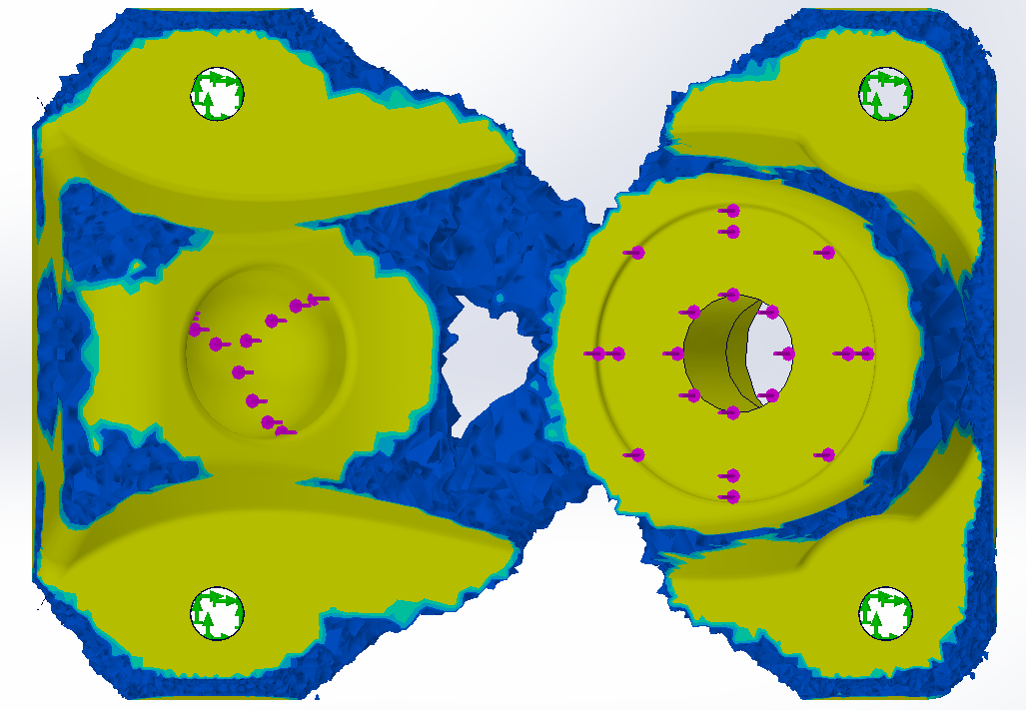
Figure 28: Optimized base plate 40% weight reduction top

Base plate 60% weight reduction:

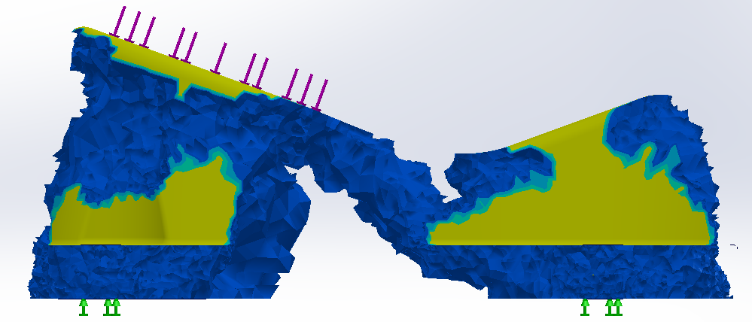
Figure 29: Optimized base plate 60% weight reduction side

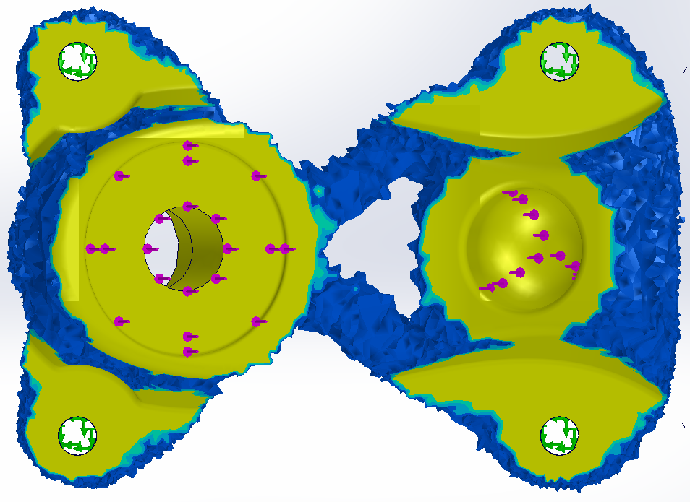
Figure 30: Optimized base plate 60% weight reduction top

Design Implications
Topology optimization simulations in SolidWorks output a mesh model (simulation results above) which cannot be edited further within SolidWorks. This means that all tangible edits to the model must be done manually using the mesh as a guideline. The next step in this process is to edit the models to roughly match the optimized shapes, then to test them again under the same load cases using finite element analysis (FEA) in SolidWorks. This will show us areas of high stress and displacement which we can use to edit the model further until we achieve satisfactory results.

These simulations were successful in that they informed us of ideal material distribution under our worst-case load scenarios. Since the 60% weight reduction results had no stress issues, excessively thin regions, or processing errors, we will be using these when moving forward with editing the models to match. Any more than 60% leads to uncertainty and very thin regions, so we stopped there satisfactorily.

Bicycle Crank Arm – Nolan
Topology Optimization Parameters
The crank arm of a bicycle is quite essential to the overall assembly of the vehicle, considering that when pushed by the user propels the bike forward, and can be used as a point of contact for the rider. I performed two different simulations for weight reduction, very similar to my partner in that the mass was reduced by 40 and 60%, as well as placed fixtures and loads where they would realistically occur on the arm.

Loads:
Crank Arm:
- 1815 N at a 45-degree angle applied at the pedal mount, based on study [25]
- Fixtures at the central shaft bore and the connections to the main gear

Conditions and constraints:
Crank Arm:
- 316L stainless steel
- Rear of Central Body is retained
- Gear Mounts and area around main shaft retained
- 40% and 60% weight reduction (separate)

Schematics
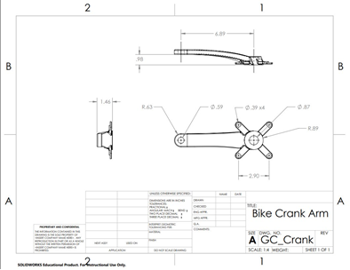
Figure 31: Crank Arm Drawing

Optimization Results
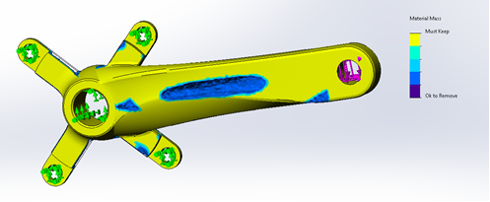
Figure 32: 40% Weight Reduction
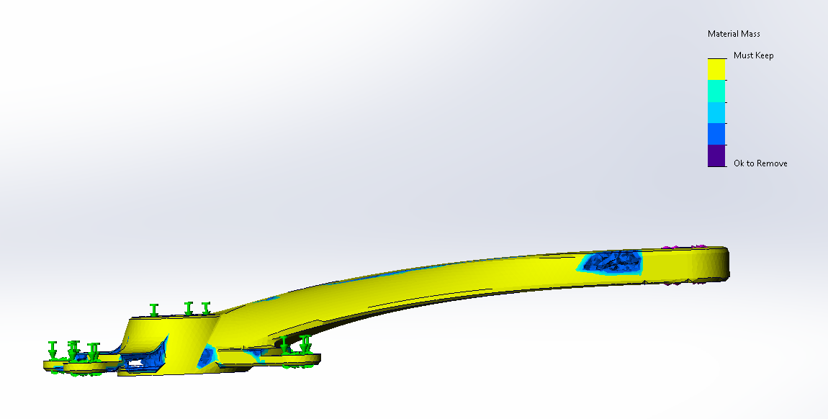
Figure 33: 40% Weight Reduction Side View
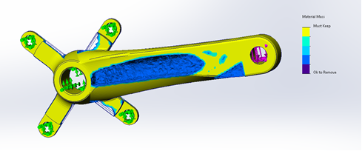
Figure 34: 60% Weight reduction
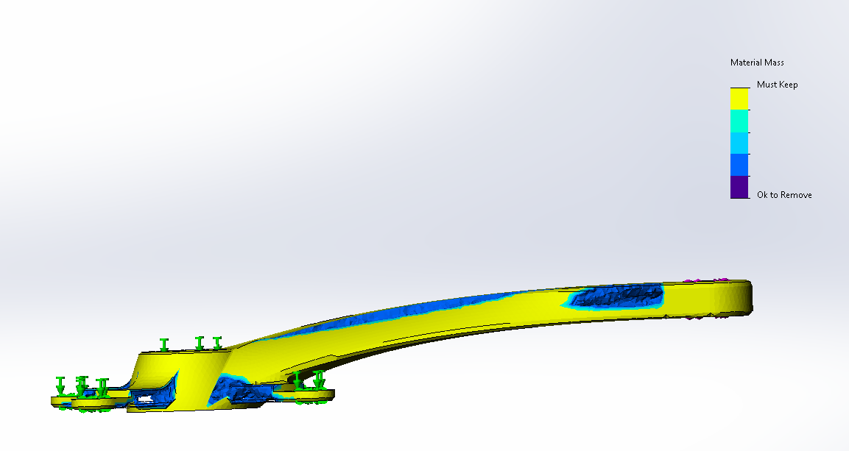
Figure 35: 60% Weight Reduction Side View

Design Implications
The program decided that the best way to reduce the weight of the crankshaft was to hollow out most of the main sections of the body and parts of the struts that connect to the gear. In addition, there are various pock marks around the body where we can potentially remove further material from further to reduce weight.

One notable limitation of the process was the output format of the optimized design. The topology study produced a mesh rather than a fully parametric CAD model, requiring manual adjustments to the original part geometry. This added complexity to the workflow, as the design must be manually refined to match the mesh recommendations before exporting to an STL file for potential 3D printing. While we considered printing the optimized design as a proof of concept, the limited availability of SS 316L powder stock made this option less feasible at this stage. However, manual refinement and STL export remain priorities for completion before the semester’s end.

Other Engineering Calculations

Topology Optimization Calculations – Nathan
This section contains both the assumptions and equations used to calculate the loads which the skateboard truck was subjected to in the topology optimization simulation.
The assumptions of this optimization regard the load conditions with which I performed the simulation. There are three separate loads I included a vertical impact load on the ends of the truck (wheels), a horizontal impact load on the ends of the truck, and a vertical impact load along the truck. In both vertical load cases, horizontal momentum is not accounted for to consider the worst-case scenario. It should be noted that while each of these load cases are for different scenarios, the topology optimization must be performed with all potential worst-case loads applied to the model at the same time to account for all situations in the result of the simulation.

Vertical impact load on ends of truck:
This load was calculated with the conditions of a 250lb person and 5.5lb skateboard falling 5 feet onto a single truck with an impact time of 0.1 seconds. The load calculated is split between both ends of the truck, as the truck would turn and intersect with the board if the load was only applied to one. The calculations for this load are as follows:

Impact velocity: $v=\sqrt{2gh}$ $g=9.81\left(\frac{m}{s^{2}}\right)$ $h=5ft=1.524m$ $v=5.47\left(\frac{m}{s}\right)$
Total mass: $m_{total}=250lb+5lb=255lb=115.89kg$
Change in momentum: $∆p=m_{total}×v=634.5kg×\left(\frac{m}{s}\right)$
Impact load: $F=\frac{∆p}{∆t}=\frac{634.5}{0.1}=6345N$

Horizontal impact load on ends of truck:
This load was calculated with the conditions of a 250lb person and 5.5lb skateboard hitting an obstacle while traveling at 10mph with an impact time of 0.1 seconds. The load calculated is applied to both ends of the truck to simulate hitting a rock or similar object and is applied to both ends of the truck separately. This is to simulate a worst-case scenario where the skateboard and person are stopped completely by a rock hitting one wheel. It is applied to both sides of the truck for symmetry in the topology optimization simulation. The calculations for this load are as follows:

Impact velocity (m/s): $v=10mph = 4.4704\left(\frac{m}{s}\right)$
Total mass: $m_{total}=250lb+5lb=255lb=115.89kg$
Change in momentum: $∆p=m_{total}×v=518.6kh×\left(\frac{m}{s}\right)$
Impact load: $F=\frac{∆p}{∆t}=\frac{518.6}{0.1}=5186N$

Vertical impact load along the truck:
This load was calculated with the conditions of a 250lb person and 5.5lb skateboard falling 3ft onto a hard surface with an impact time of 0.1 seconds. This is to simulate a person attempting to grind along a ledge, rail, or other surface in which all the force is directed along the truck and bypasses the wheels. The calculations for this load are as follows:

Impact velocity (m/s): $v=\sqrt{2gh}$ $g=9.81\left(\frac{m}{s^{2}}\right)$ $h=3ft=0.9144m$ $v=4.24\left(\frac{m}{s}\right)$
Total mass: $m_{total}=250lb+5lb=255lb=115.89kg$
Change in momentum: $∆p=m_{total}×v=492.7kg×\left(\frac{m}{s}\right)$
Impact load: $F=\frac{∆p}{∆t}=\frac{492.7}{0.1}=4927N$

Future Testing Potential
In the future, we plan on finally printing parts using the machine. Initially we plan on purely printing some parts to determine any issues that may arise with the functions of the machine itself and hammering out any sort of issues that may arise. These include, but are not limited to, Z-axis calibration, coater speed calibration, and average time to print. After which, we plan on fully moving into specimen testing, which would include comparing stress-strain results between a traditionally manufactured part, a machined part using printed stock, and a purely printed part. This will help compare the strength of a printed part to traditionally made parts so that future students can decide if it is optimal for them to print the part they need.

CONCLUSIONS
The Metal 3D Printer Capstone project aims to commission the IDEA Lab's Concept Laser mLab100R. This involves setting up the machine, ensuring it works properly through testing, and troubleshooting any issues we encounter. The team will print test parts to assess the printer's performance, print a final part to demonstrate its capabilities, and create usage instructions for IDEA Lab managers. The goal is to confirm that the printer meets typical industrial standards for accuracy, quality, and safety, enabling consistent high-quality metal part production for future student use.

REFERENCES
[1] “GE ATLAS,” VoxelMatters - The heart of additive manufacturing, 2017. https://www.voxelmatters.com/top-products/ge-atlas/ (accessed Oct. 22, 2024).

[2] “The most advanced metal binder jetting system for sustainable, high-quality production.” Accessed: Oct. 22, 2024. [Online]. Available: https://www.exone.com/getattachment/7615e118-81ea-47d3-97f8-86a2451e7162/x1-160pro-data-sheet-07062020.pdf

[3] “Metal Additive Manufacturing with EBAM® Technology | Sciaky,” Sciaky.com, 2019. https://www.sciaky.com/additive-manufacturing/electron-beam-additive-manufacturing-technology

[4] Hofmann Innovation Group. (2015). Concept Laser Operating Manual, Type: Mlab cusing R. Concept Laser.

[5] Sutton, A. T., Kriewall, C. S., Leu, M. C., & Newkirk, J. W. (2016). "Powder characterisation techniques and effects of powder characteristics on part properties in powder-bed fusion processes." Virtual and Physical Prototyping, 12(1), 3–29. https://doi.org/10.1080/17452759.2016.1250605

[6] Sun, S., Brandt, M., & Easton, M. (2017). "Powder bed fusion processes: An overview." ScienceDirect. https://www.sciencedirect.com/science/article/pii/B9780081004333000026

[7] Bartlett, J. L., & Li, X. (2019). "An overview of residual stresses in metal powder bed fusion." Additive Manufacturing, 27, 131–149. https://doi.org/10.1016/j.addma.2019.02.020

[8] AddUp. (2023). "Surface Finish for 3D Printed Tooling: Advancing PBF Technology as a Production Tool | Blog." AddUp Solutions, October 5, 2023. https://addupsolutions.com/surface-finish-for-3d-printed-tooling-advancing-pbf-technology-as-a-production-tool-blog/

[9] Materion. (2024). "Stress-Strain Concepts: Why They Matter in Materials Testing." Materion.com, July 22, 2024. https://www.materion.com/en/insights/blog/stress-strain-concepts-materials-testing

[10] Materion. (2024). "All About Tensile Testing: How to Set Up Your Samples for Accurate Results." Materion.com, June 17, 2024. https://www.materion.com/en/insights/blog/All-About-Tensile-Testing

[11] P. Konda Gokuldoss, Selective Laser Melting: Materials and Applications. MDPI AG, 2020.

[12] N. H. Kim, A. V. Kumar, and B. V. Sankar, Introduction to finite element analysis and design, Second edition. Hoboken, New Jersey: John Wiley & Sons, 2018.

[13] “Research of 316L Metallic Powder for Use in SLM 3D Printing,” Advances in Materials Science/Advances in Materials Sciences, 2020, doi: 10.2478/adms-2020-0001.

[14] D. Gogolewski, T. Bartkowiak, T. Kozior, and P. Zmarzły, “Multiscale Analysis of Surface Texture Quality of Models Manufactured by Laser Powder-Bed Fusion Technology and Machining from 316L Steel,” Materials, vol. 14, no. 11, pp. 2794-, 2021, doi: 10.3390/ma14112794.

[15] W. Zhang, J. Zhu, and T. Gao, Topology optimization in engineering structure design. London, [England]; ISTE Press, 2016.

[16] F3184 Standard Specification for Additive Manufacturing Stainless Steel Alloy (UNS S31603) with Powder Bed Fusion. 2023. doi: 10.1520/F3184-16R23.

[17] “Topology Optimization 101: How to Use Algorithmic Models to Create Lightweight Design,” Formlabs. https://formlabs.com/blog/topology-optimization/

[18] Loughborough University, “Powder Bed Fusion | Additive Manufacturing Research Group | Loughborough University,” Lboro.ac.uk, 2010. https://www.lboro.ac.uk/research/amrg/about/the7categoriesofadditivemanufacturing/powderbedfusion/

[19] “Metal 3D Printer Precision System | Objective 3D,” Objective3D, Feb. 18, 2024. https://www.objective3d.com.au/product/concept-laser-mlabs/ (accessed Sep. 18, 2024).

[20] J. Hirschtik. SolidWorks. (2023). Dassault Systèmes SOLIDWORKS Corp. [Application]. Available: https://www.solidworks.com

[21] F3592 Standard Guide for Additive Manufacturing of Metals – Powder Bed Fusion – Guidelines for Feedstock Re-use and Sampling Strategies. 2023. doi: 10.1520/F3592-23.

[22] “Additive manufacturing of metals — Finished part properties — Post-processing, inspection and testing of parts produced by powder bed fusion,” Astm.org, 2014. https://www.astm.org/f3591-23.html

[23] R. C. Hibbeler, Mechanics of Materials. Pearson Higher Ed, 2011.

[24] “Standard Practice for Reporting Data for Test Specimens Prepared by Additive Manufacturing,” Astm.org, 2021. https://www.astm.org/f2971-13r21.html (accessed Nov. 28, 2024).

[25] P. D. Soden and B. A. Adeyefa, “Forces applied to a bicycle during normal cycling,” Journal of Biomechanics, vol. 12, no. 7, pp. 527–541, Jan. 1979, doi: https://doi.org/10.1016/0021-9290(79)90041-1.

